

Practices for Secure Software Report

Table of Contents
Document Revision History 3
Client 3
Instructions 3
Developer 4
1. Algorithm Cipher 4
2. Certificate Generation 4
3. Deploy Cipher 4
4. Secure Communications 4
5. Secondary Testing 4
6. Functional Testing 4
7. Summary 4
8. Industry Standard Best Practices 4

Document Revision History

Version | Date | Author | Comments
1.0 | 04/17/26 | Herminia Campuzano

Client



Instructions

Submit this completed practices for secure software report. Replace the bracketed text with the relevant information. You must document your process for writing secure communications and refactoring code that complies with software security testing protocols.

- Respond to the steps outlined below and include your findings.
- Respond using your own words. You may also choose to include images or supporting materials. If you include them, make certain to insert them in all the relevant locations in the document.
- Refer to the Project Two Guidelines and Rubric for more detailed instructions about each section of the template.

Developer
Herminia Campuzano

Algorithm Cipher

For this project, I used the SHA-256 hashing and HTTPS with SSL/TLS to provide secure communication. SHA-256 is part of the SHA-2 family and it takes input data and turns it into a fixed 256-bit hash value. This hash works like a fingerprint so if the data changes even a little the hash will also change. SHA-256 is a one-way function which means you can’t reverse it back to the original data. This is important for security because it helps protect sensitive information and makes sure data hasn’t changed. It also helps reduce collisions where two different inputs could end up with the same hash which is very unlikely with SHA-256.
For communication, I used HTTPS with SSL/TLS. This adds encryption between the client and server so the data is protected while it is being transmitted, SSL/TLS uses keys to encrypt data. There are two types of encryptions symmetric and asymmetric. Symmetric uses one shared key while asymmetric uses two keys. In this project, RSA is used, which is an asymmetric algorithm and it works with the certificate to help create a secure connection.

Certificate Generation
Insert a screenshot below of the CER file.
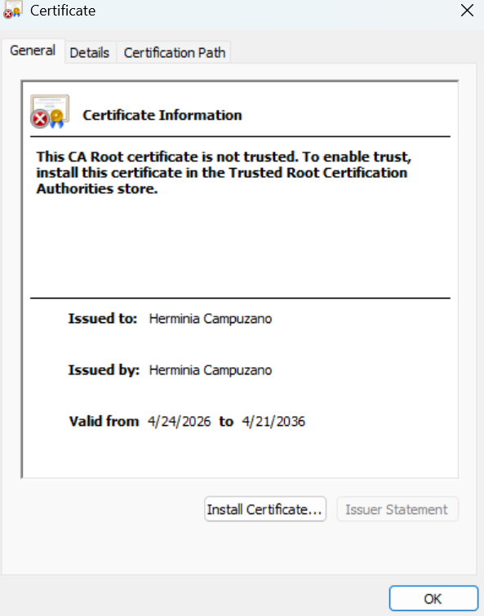
Self-signed certificate, shows certificate issuer, subject and validity period

Deploy Cipher
Insert a screenshot below of the checksum verification.
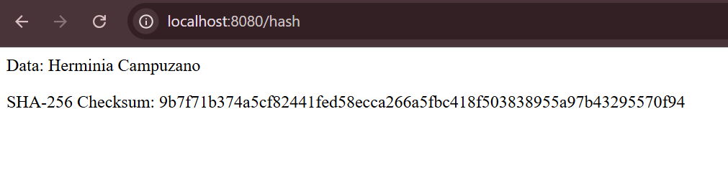
SHA-256 checksum generated by the application over HTTP, which show the original data input and corresponding hash value

Secure Communications
Insert a screenshot below of the web browser that shows a secure webpage.

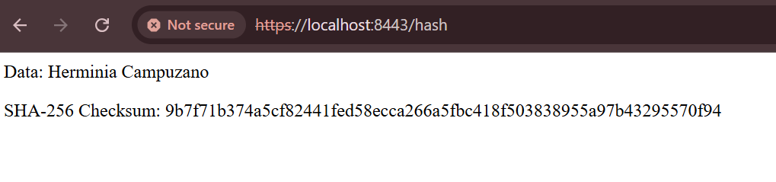

Secure HTTPS connection displaying encrypted communication using SSL/TLS on localhost

Secondary Testing
Insert screenshots below of the refactored code executed without errors and the dependency-check report.

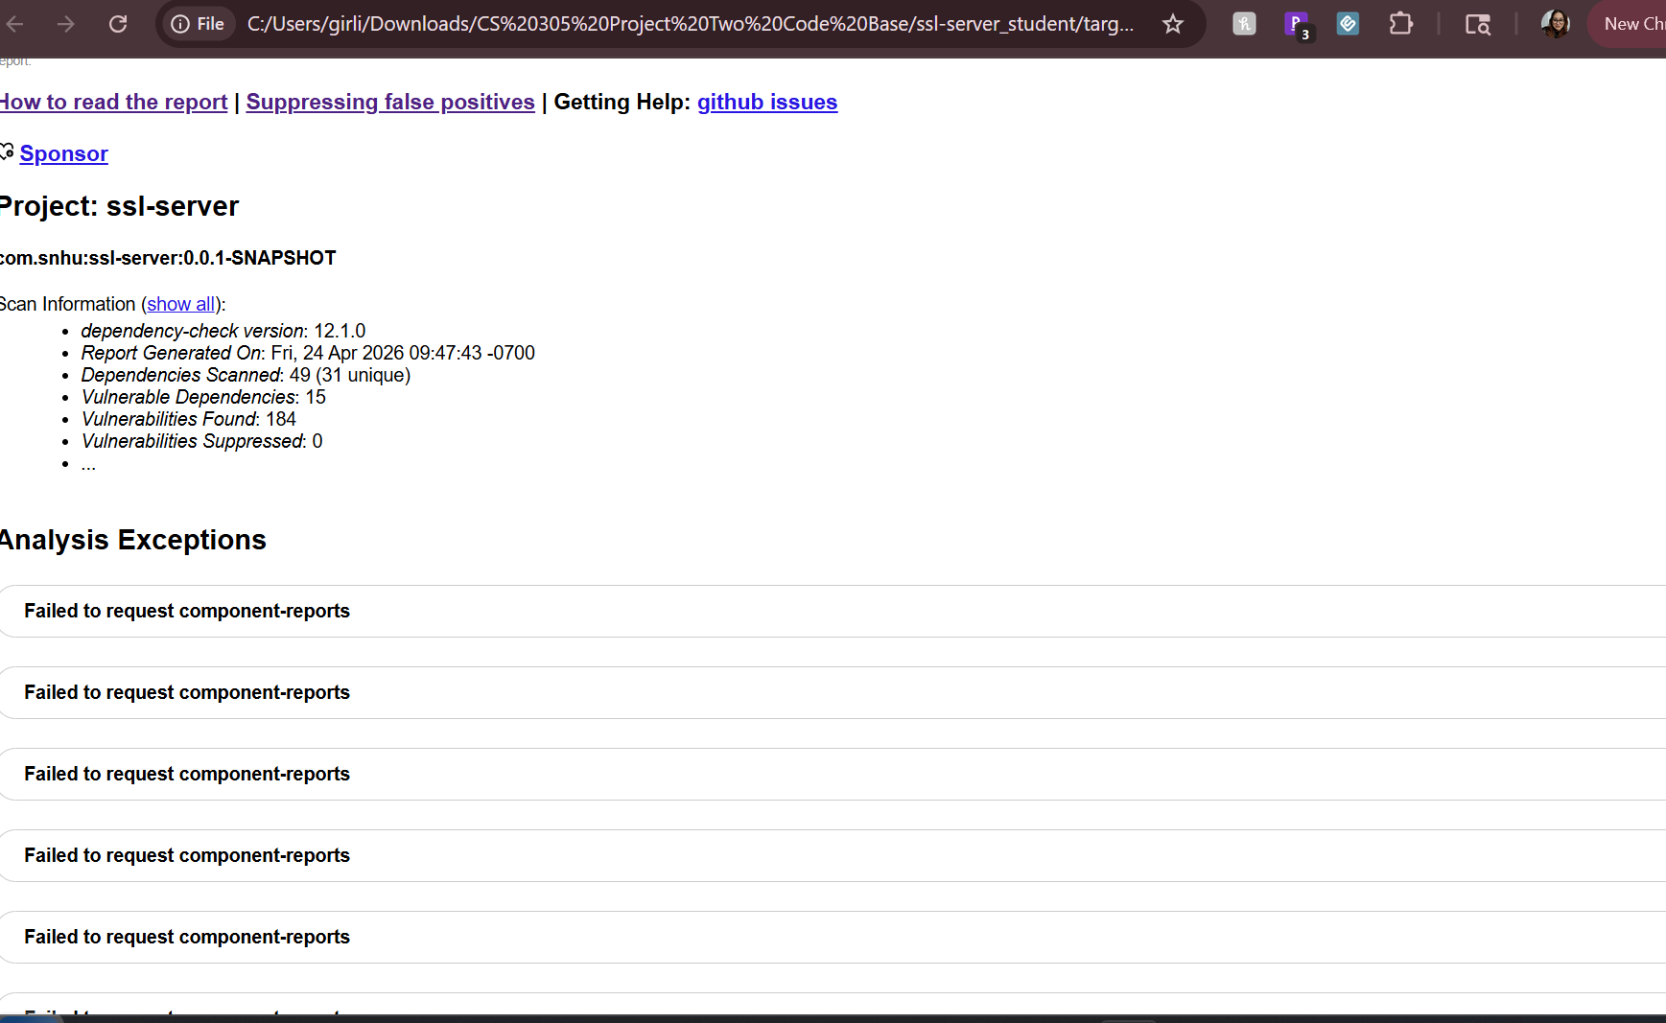
Owasp Dependency-Check HTML report showing vulnerability analysis results

Functional Testing
Insert a screenshot below of the refactored code executed without errors.

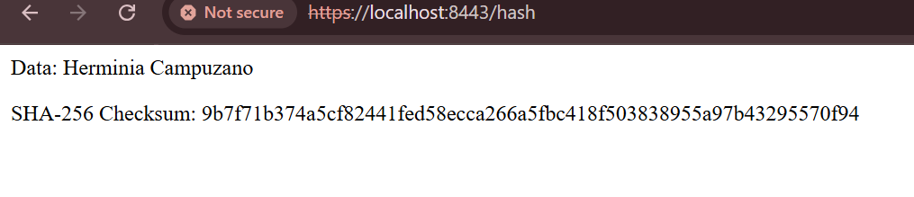

Application running successfully, confirming the refactored code executes without errors after implementation of security features

Summary

For this project, I made some changes to the application to make it more secure. I basically went step by step. First I looked at what could be a risk then I made updates and after that I tested it to make sure everything was still working. One thing I added was SHA-256 hashing. This helps keep the data from being changed and you can’t really reverse it back. I also set up HTTPS using SSL/TLS so the connection between the client and server is secure. That way the data is protected while it’s being sent.
After that I used the OWASP Dependency-Check tool to scan the project. This was mainly to see if any of the libraries being used had known problems. It did show some existing vulnerabilities but nothing new came from the changes I made. Overall, I added a few layers of security like hashing, HTTPS and scanning. It’s not perfect but it does make the application more secure and safer to use.

Industry Standard Best Practices

For this project, I followed some basic secure coding practices to make the application more secure. I added SHA-256 hashing, enabled HTTPS and used a certificate so the connection between the client and server is secure. These changes help protect the data so it’s not easily changed or seen by someone else. I also ran the OWASP Dependency-Check tool to look at the dependencies used in the project. Sometimes security issues don’t come from your own code but from the libraries you’re using. This helped me check if anything already had known vulnerabilities. It did show some existing issues but they were not caused by the changes I made.
Overall, these practices help keep the application more secure. Since Artemis Financial deals with sensitive financial data, it’s important to reduce risks as much as possible. Even small changes like this can help protect user data and avoid bigger problems later.

References
GeeksforGeeks. (2025, July 15). Cryptographic hash function in Java. https://www.geeksforgeeks.org/java/cryptographic-hash-function-in-java/
What is the SHA-256 algorithm & how it works - SSL dragon. (n.d.). https://www.ssldragon.com/blog/sha-256-algorithm/
Hash Tools. (n.d.). How to create a secure hashing algorithm from scratch. https://www.hash.tools/115/cryptographic-algorithms/1974/how-to-create-a-secure-hashing-algorithm-from-scratch

